**Operation Christmas Child**

**True Life Church Children’s Ministry is asking for donations for our Operation Christmas Child outreach through Samaritans Purse.**

-We will be collecting items here until Nov 18. We will pack these gift items into a shoe box size gift box.

-The evening of Nov. 18, our Wednesday evening activity will have our Children learn about other children around the world who receive these gift boxes. Our children will pack the shoeboxes, include a personal message for child who opens the box. We want to encourage children around the world to know Good News about Jesus Christ.

-Boxes will then be delivered to a local collection site to begin the journey to a child who may not have ever received a gift.

**Shoebox gifts\***

Some ideas: WOW items a small stuff toy, deflated soccer ball (include small air pump), small toy, an outfit maybe a harmonica or wind flute.

**Personal care items:** combs, hair brush, soap, washcloth, toothbrush, bandages, Reusable plastic containers: cup, water bottle, plate, bowl, blunt-edged utensils  
(Consider filling an empty container with non-liquid items such as combs, markers, sunglasses, hair bows, bracelets or washcloths to maximize the space.)

**School supplies**: Pencils, pens, markers, crayons, colored pencils, small manual pencil sharpener, erasers, notebooks, scissors, rulers, solar powered calculators, index cards, tape,

**Clothing items**: socks, underwear, scarfs, mittens or gloves, friendship bracelets, jump rope, outfits, shirts, pants, hair ribbons,

**Craft and fun items**: puzzles, stickers, colored chalk, coloring books, yoyos, foam balls, hacky sack,

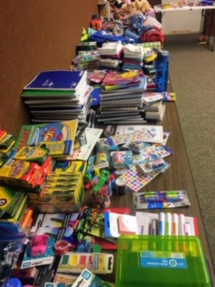 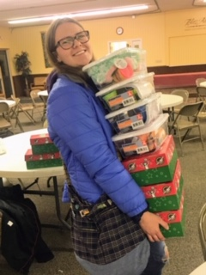 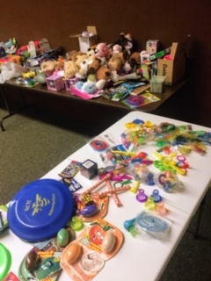

**\*Pease do not include these items**: Candy; toothpaste; gum; used or damaged items; war-related items such as toy guns, knives, or military figures; chocolate or food; seeds; fruit rolls or other fruit snacks; drink mixes (powdered or liquid); liquids or lotions; medications or vitamins; breakable items such as snow globes or glass containers; aerosol cans